Hands-on Projects

These projects should be completed in the order given. The hands-on projects presented in this chapter should take a total of three hours to complete. The requirements for this lab include:

* A computer with Fedora Linux installed according to Hands-on Project 2-1 and Ubuntu Server Linux installed according to Hands-On Project 6-1.

# Project 10-1

In this hands-on project, you use commands to create and configure a printer as well as submit and manage print jobs.

1. Boot your **Fedora** Linux virtual machine. Login to your chosen desktop environment as **user1** using password **LNXrocks!** and open up a terminal window.
2. At the terminal, become **root** by typing **su -** and press enter and provide **LNXrocks!** as the password.
3. At the command prompt, type **lpadmin -p printer1 -E -v /dev/null -m raw** and press Enter to create a sample printer called printer1 that prints to the /dev/null device using a raw print driver.
4. At the command prompt, type **lpoptions -d printer1** and press Enter to ensure that printer1 is the default printer on the system.
5. At the terminal screen prompt, type **cat /etc/cups/printers.conf** and press Enter. Do you see an entry for printer1 that prints to /dev/null? **yes**
6. At the command prompt, type **lpstat -t** and press Enter. Is the CUPS daemon running? **No.** Is printer1 enabled and accepting requests? **Yes.** Is printer1 the default printer on the system? **Yes**
7. At the command prompt, type **cupsdisable -r "To keep print jobs in the queue" printer1** and press Enter to disable printer1 with an appropriate reason. Next, type **lpstat -t** at the command prompt and press Enter. Is printer1 disabled with a reason? **Yes**
8. At the command prompt, type **lp -n 2 /etc/inittab** and press Enter to print two copies of /etc/inittab to printer1. What is the print job ID? **printer1-1** Why did you not need to specify the printer name when running the lp command? **Because it is the default.**
9. At the command prompt, type **lp /etc/hosts /etc/nsswitch.conf** and press Enter to print the /etc/hosts and /etc/nsswitch.conf files. What is the print job ID? **printer1-2**
10. At the command prompt, type **mount | lp** and press Enter to print the output of the mount command to printer1. What is the print job ID? **printer1-3**
11. At the command prompt, type **lpstat** and press Enter. Are your print jobs shown in the queue? How long will they remain in the queue and why? **Yes, and it will stay in there until the printer is enabled or the user deletes them.**
12. At the command prompt, type **ls /var/spool/cups** and press Enter. You should notice contents within this directory for your three print jobs. The data for your print jobs should have file names that start with d, and the settings for your print jobs should have file names that start with c. Type **cat /var/spool/cups/d00001-001** at the command prompt and press Enter to view the data for the first print job on the system. What is shown and why? **I’m seeing what it’s going to print.**
13. At the command prompt, type **cancel printer1-1** and press Enter to remove the first print job from the queue. Next, type **lpstat printer1** at the command prompt and press Enter. Has the printer1-1 job been removed? **Yes**
14. At the command prompt, type **lpc status** and press Enter to view the status of CUPS using the traditional BSD lpc command. Is the CUPS daemon running? **Yes.**  Is the status of printing and spooling correct? **Yes.** Next, type **lpq** at the command prompt and press Enter. Do you see the two remaining jobs in the print queue for printer1? Do the job numbers displayed correspond with the job numbers in the lpstat output from the previous step? **No, because it says that the printer1 is not ready.**
15. At the command prompt, type **lpr -#2 /etc/inittab** and press Enter to print two copies of /etc/inittab to the default printer using the traditional BSD lpr command. Next, type lpq at the command prompt and press Enter. Do you see an additional job in the print queue? What is the job ID? **Yes, the job ID is 4.**
16. At the command prompt, type **lprm 4** and press Enter to remove the most recent print job that you submitted. Next, type **lpq** at the command prompt and press Enter.
17. **Provide screenshot(s) of steps 3 through 15.**

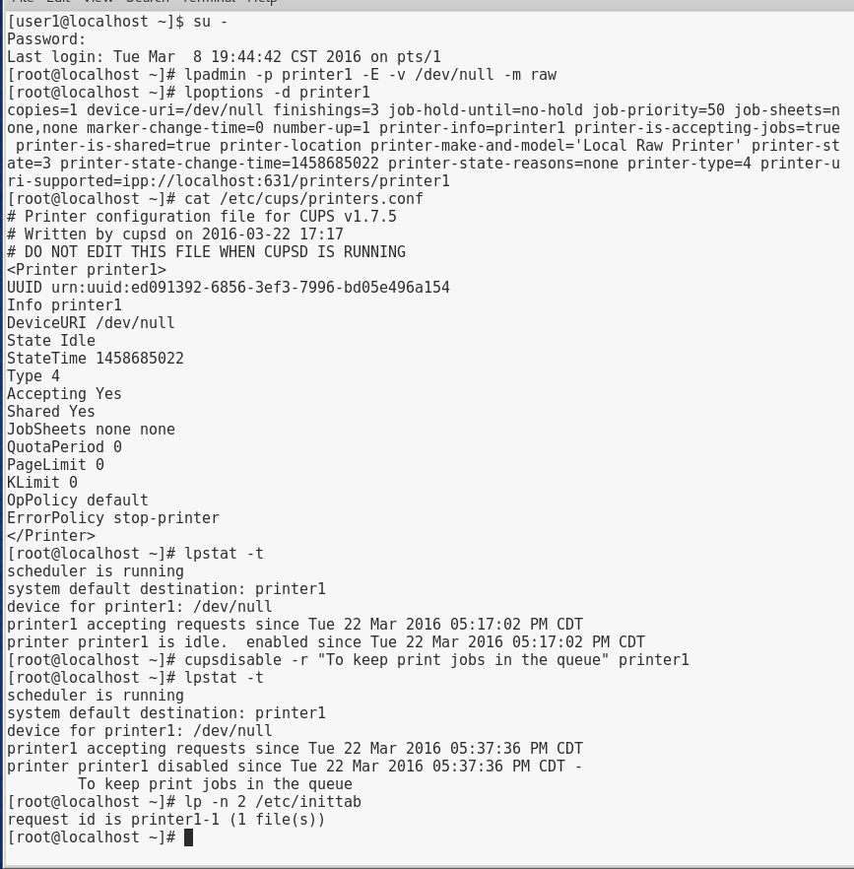

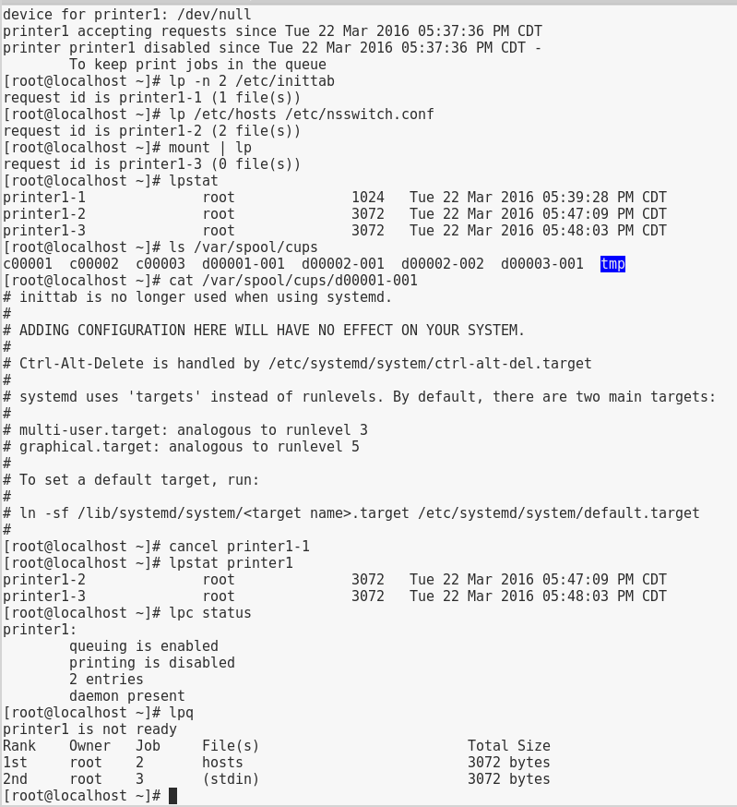

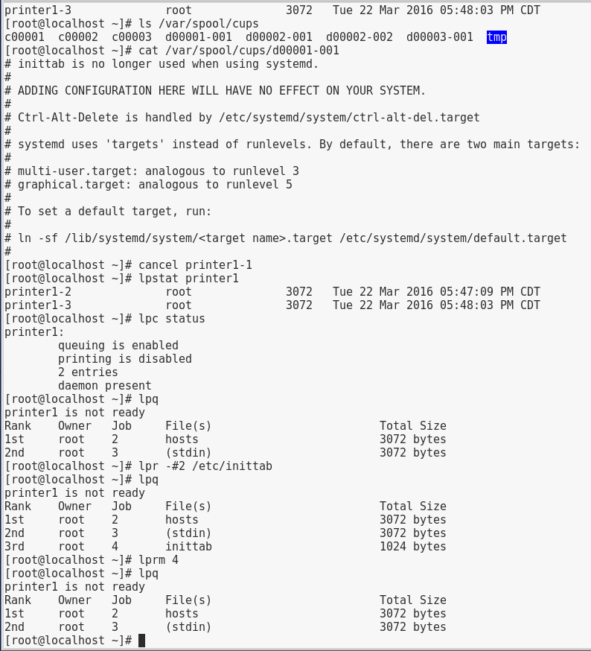

# Project 10-2

In this hands-on project, you view the configuration of the System Log Daemon and the logrotate utility on Ubuntu Server Linux.

1. Boot your **Ubuntu** Linux virtual machine. Login to your chosen desktop environment as **user1** using password **LNXrocks!** and open up a terminal window.
2. At the command prompt, type **ll /dev/log** and press Enter. What is the file type? Which daemon on Ubuntu Server Linux uses this file and what is its purpose? **Socket and for sys log**
3. At the command prompt, type **less /etc/rsyslog.conf** and press Enter to view the configuration file for the System Log Daemon. Are there any entries that specify facilities, priorities, or log file locations? What does the last line of the file specify? **Yes, the last line says $IncludeConfig /etc/rsyslog.d/*.conf** Press q when finished to quit the less utility.
4. At the command prompt, type **less /etc/rsyslog.d/50-default.conf** and press Enter. Where do kernel messages of any priority get logged to by default? **-/var/log/kern.log** What does the – character next to the filename indicate? **It prevents sinking of the log files.** Press q when finished to quit the less utility.
5. At the command prompt, type **tail /var/log/kern.log** and press Enter. Observe the entries.
6. At the command prompt, type **ls /var/log/cups** and press Enter. What daemon creates the log files within the /var/log/cups directory? **Access_log error_log page_log**
7. At the command prompt, type **cat /etc/cron.daily/logrotate** and press Enter to observe the logrotate command that is run each day.
8. At the command prompt, type **less /etc/logrotate.conf** and press Enter to view the configuration file for the logrotate command. How many copies of old log files are kept by default? **4 Weeks worth** When finished, press q to quit the less utility.
9. At the command prompt, type **ls /etc/logrotate.d** and press Enter. How many files are in this directory? Will entries in these files override the same entries in /etc/logrotate.conf? **There are 21 and no.**
10. At the command prompt, type **cat /etc/logrotate.d/cups-daemon** and press Enter. How many copies of old log files are kept for the log files in the /var/log/cups directory? Will the log files be rotated if they contain no contents? **11**
11. **Provide screenshot(s) of steps 3 through 10.**

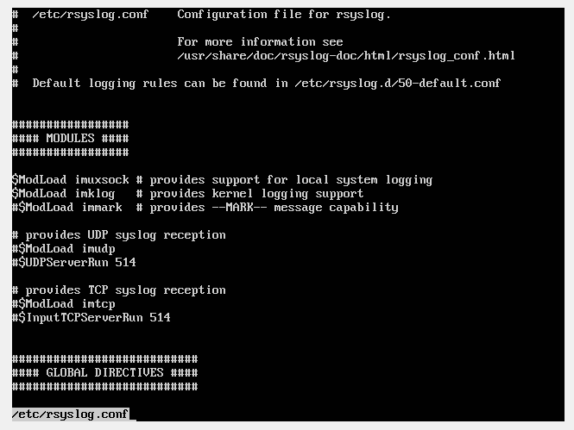

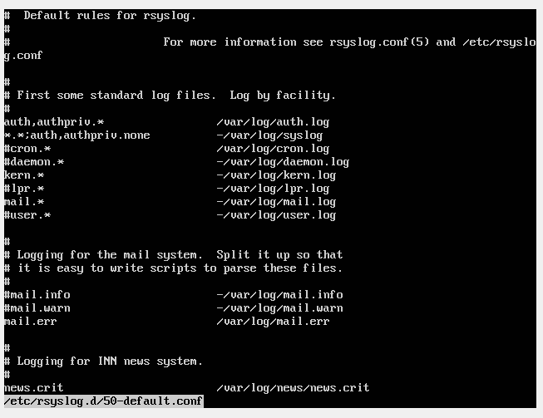

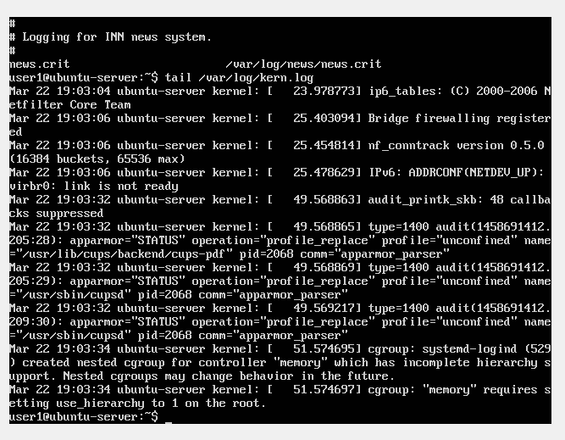

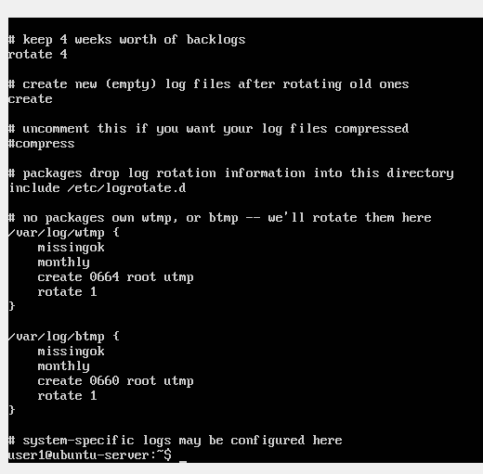

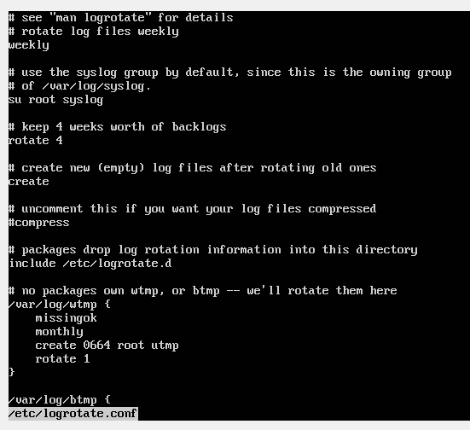

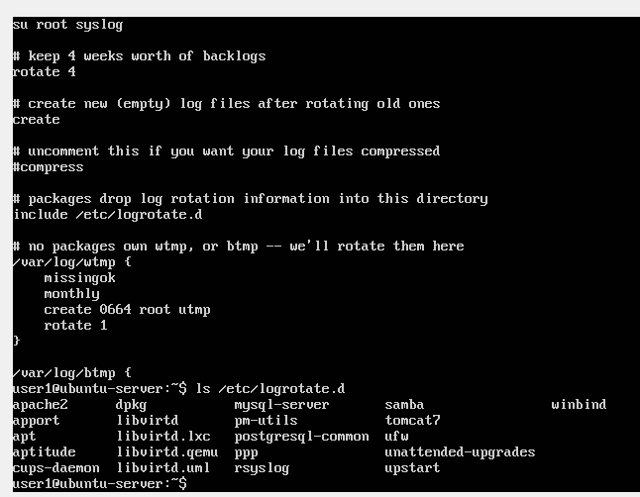

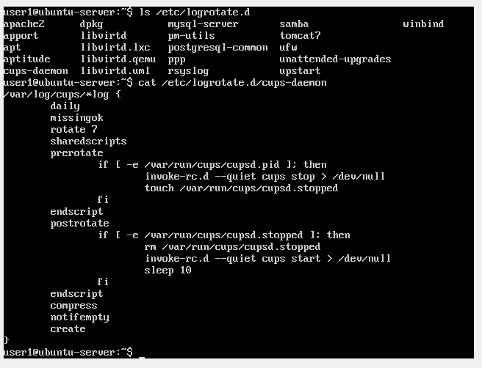

# Project 10-3

In this hands-on project, you view the configuration and log entries created by the Systemd Journal Daemon as well as the configuration of the logrotate utility on Fedora Linux.

1. Boot your **Fedora** Linux virtual machine. Login to your chosen desktop environment as **user1** using password **LNXrocks!** and open up a terminal window.
2. At the terminal, become **root** by typing **su -** and press enter and provide **LNXrocks!** as the password.
3. At the command prompt, type **ll /dev/log** and press Enter. What is the file type? Which daemon on Fedora Linux uses this file and what is its purpose? **The file type is socket and for sys log.**
4. At the command prompt, type **cat /etc/systemd/journald.conf** and press Enter to view the configuration file for the Systemd Journal Daemon. What line could you uncomment and configure to set a maximum size for the journald database? **SystemMaxUse**
5. At the command prompt, type **journalctl _COMM=** and press the Tab key twice. Which keyword could you use to view log entries from the GNOME display manager? **Gdm** Press Ctrl + c to return to your command prompt. Next, type **journalctl _COMM=gdm** and press Enter to view log entries from the GNOME display manager. Are entries shown for multiple days? **yes**
6. At the command prompt, type **journalctl _COMM=gdm --since "5:00"** and press Enter to view log entries from the GNOME display manager since 5:00am.
7. At the command prompt, type **which crond** and press Enter. What is the path to the cron daemon executable file? **/sbin/crond** Next, type **journalctl /sbin/crond --since "5:00"** and press Enter. What entries are shown?
8. At the command prompt, type **ls /var/log** and press Enter. Observe the entries. Are there log files within /var/log created by daemons that do not log entries via journald?
9. At the command prompt, type **ls /var/log/cups** and press Enter. Are the contents similar to those from Step 6 in Project 10-3? **no**
10. At the command prompt, type **cat /etc/cron.daily/logrotate** and press Enter to observe the logrotate command that is run each day.
11. At the command prompt, type **less /etc/logrotate.conf** and press Enter to view the configuration file for the logrotate command. How many copies of old log files are kept by default? When finished, press q to quit the less utility.
12. At the command prompt, type **ls /etc/logrotate.d** and press Enter. How many files are in this directory? Will entries in these files override the same entries in /etc/ logrotate.conf? **13 and no**
13. At the command prompt, type **cat /etc/logrotate.d/cups** and press Enter. How many copies of old log files are kept for the log files in the /var/log/cups directory? Will the log files be rotated if they contain no contents? **3 and yes**
14. **Provide screenshot(s) of steps 3 through 13.**

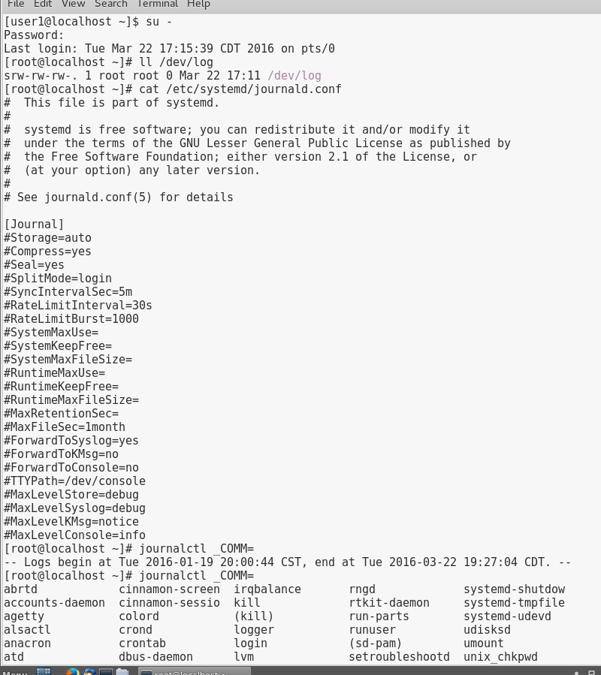

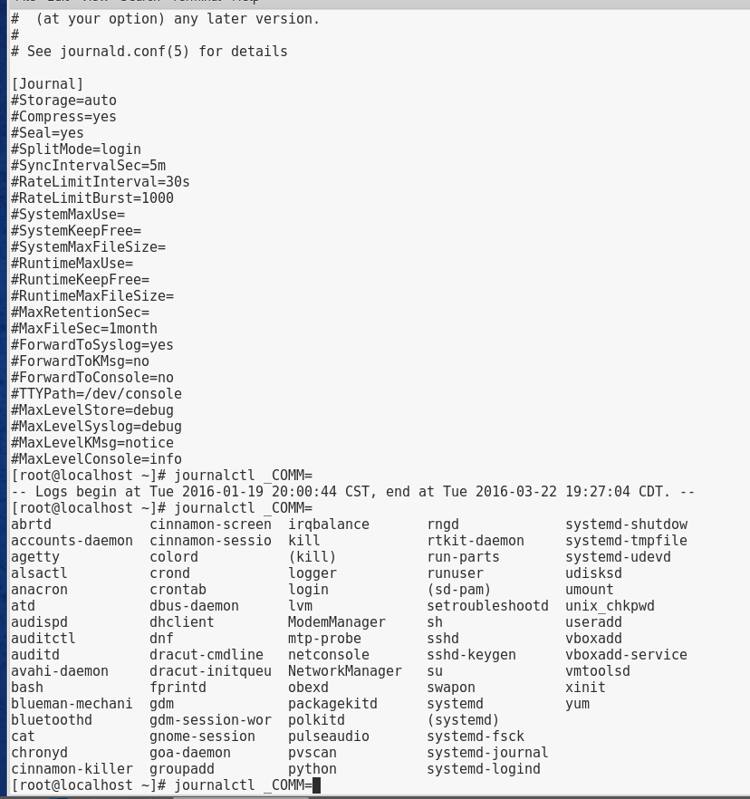

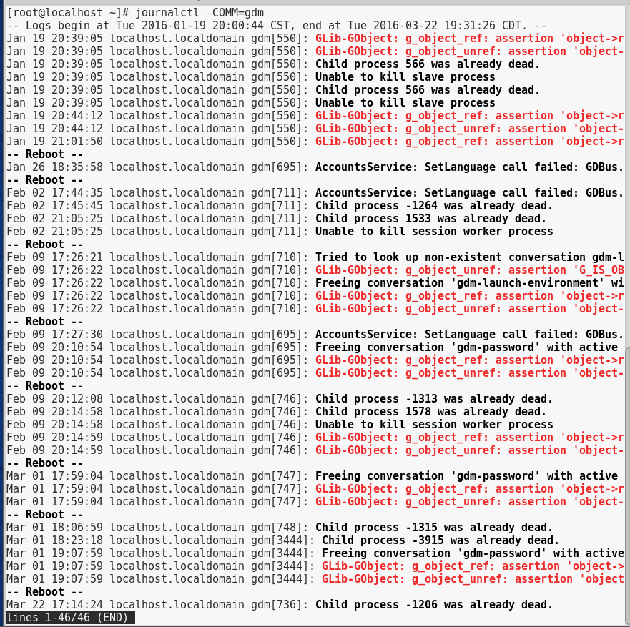

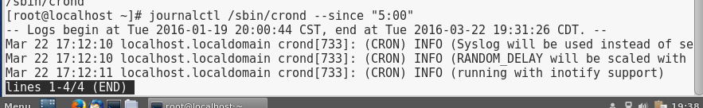

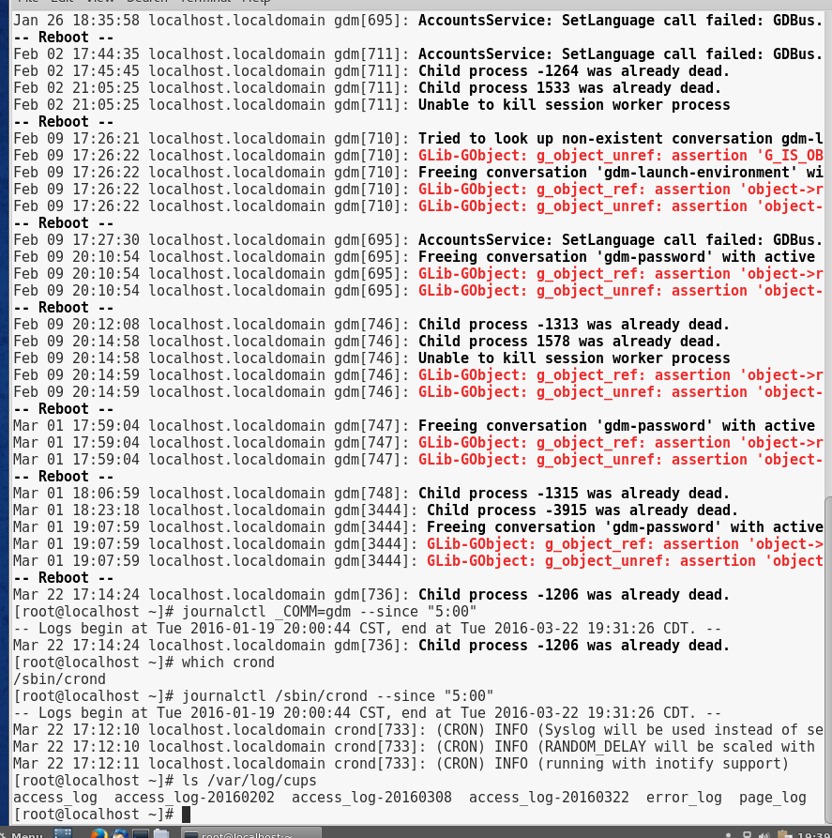

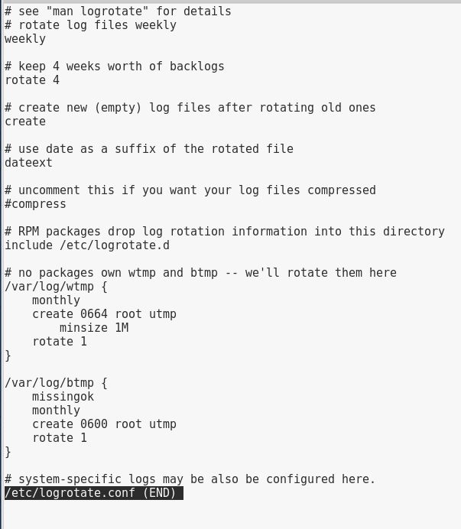

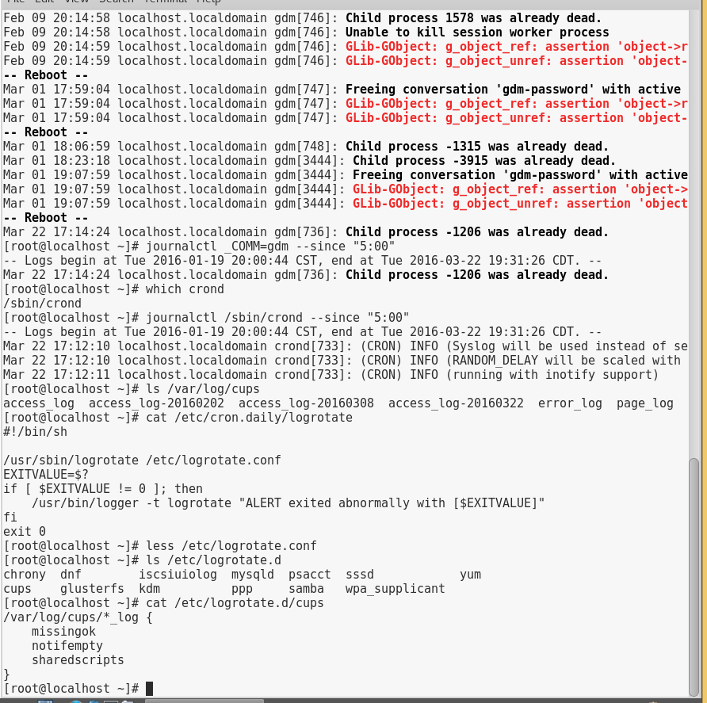

# Project 10-4

In this hands-on project, you observe user account databases on Fedora Linux and create a user account using command-line utilities.

1. Boot your **Fedora** Linux virtual machine. Login to your chosen desktop environment as **user1** using password **LNXrocks!** and open up a terminal window.
2. At the terminal, become **root** by typing **su -** and press enter and provide **LNXrocks!** as the password.
3. At the command prompt, type **less /etc/passwd** and press Enter. Where is the line that describes the root user located in this file? **Root:x:0:0:root:/root:/bin/bash** Where is the line that describes the user1 user in this file? How many daemon accounts are present? **User1:x:1000:1000:user1:/home/user1:bin/bash** What is in the password field for all accounts? When finished, press the q key to quit the less utility.
4. At the command prompt, type **ll /etc/passwd** and press Enter. Who is the owner and group owner of this file? Who has permission to read this file? **Root, and the group and other users have permission to read**
5. At the command prompt, type **less /etc/shadow** and press Enter. What is in the password field for the root user and user1 user accounts? What is in the password field for most daemon accounts? Press the q key to quit the less utility.
6. At the command prompt, type **ll /etc/shadow** and press Enter. Who is the owner and group owner of this file? Who has permission to read this file? Compare the permissions for /etc/shadow to those of /etc/passwd obtained in Step 3 and explain the difference. **root**
7. At the command prompt, type **pwunconv** and press Enter. Next, type **less /etc/shadow** at the command prompt and press Enter. What error message do you receive? Why? **No such file or directory**
8. At the command prompt, type **less /etc/passwd** and press Enter. What is in the password field for all accounts? Why? When finished, press the q key to quit the less utility.
9. At the command prompt, type **pwconv** and press Enter. What does the pwconv command do? **It allows you to use /etc/shadow**
10. Next, type **less /etc/shadow** at the command prompt and press Enter. Verify that the file has contents and press q when finished. Next, type **less /etc/passwd** at the command prompt and press Enter. Verify that the file has contents and press q when finished.
11. At the command prompt, type **cat /etc/default/useradd** and press Enter. What is the default shell used when creating users? What is the default location of the skel directory used when creating users? Where are user home directories created by default?
12. At the command prompt, type **ls -a /etc/skel** and press Enter. What files are stored in this directory? What is the purpose of this directory when creating users?
13. At the command prompt, type **cp /etc/inittab /etc/skel** and press Enter to create a copy of the inittab file in the /etc/skel directory.
14. At the command prompt, type **useradd -m bozo** and press Enter. What does the –m option specify? From where is the default shell, home directory information taken? **Creates the home directory**
15. At the command prompt, type **less /etc/login.defs** and press Enter. Observe the entries and descriptive comments. Did you need to specify the -m option to the useradd command in Step 13? Explain. Press the q key to quit the less utility.
16. At the command prompt, type **cat /etc/passwd** and press Enter. What shell and home directory does bozo have? What is bozo’s UID?
17. At the command prompt, type **cat /etc/shadow** and press Enter. Does bozo have a password? Can bozo log in to the system? **No such file or directory**
18. At the command prompt, type **passwd bozo** and press Enter. Enter the password of LNXrocks! and press Enter. Enter the password of LNXrocks! again to confirm and press Enter.
19. At the command prompt, type **ls -a /home/bozo** and press Enter. How many files are in this directory? Compare this list to the one obtained in Step 11. Is the inittab file present? **yes**
20. **Provide screenshot(s) of steps 3 through 19.**

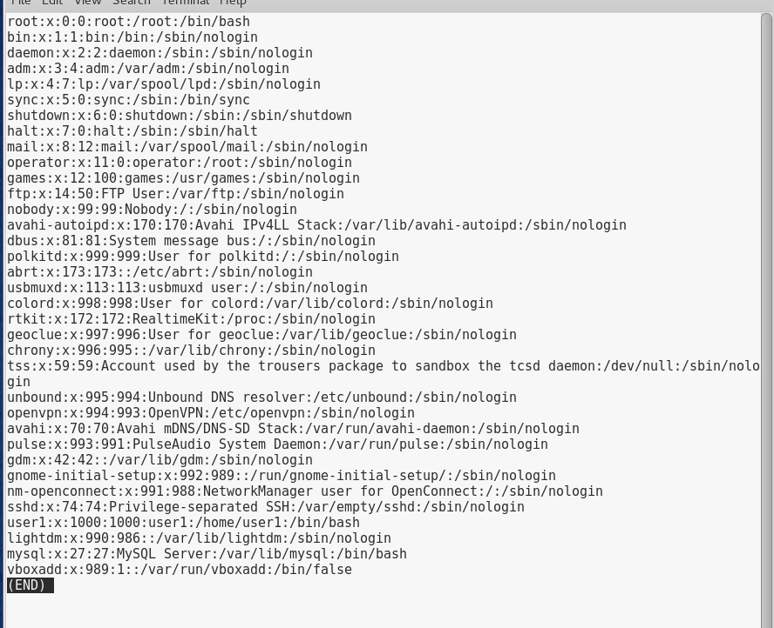



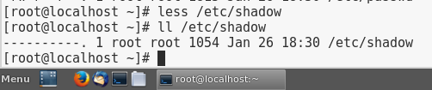

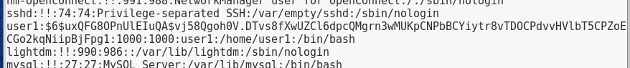

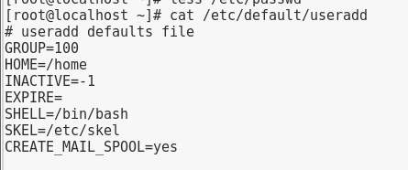

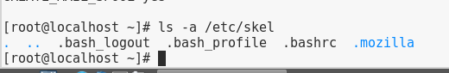

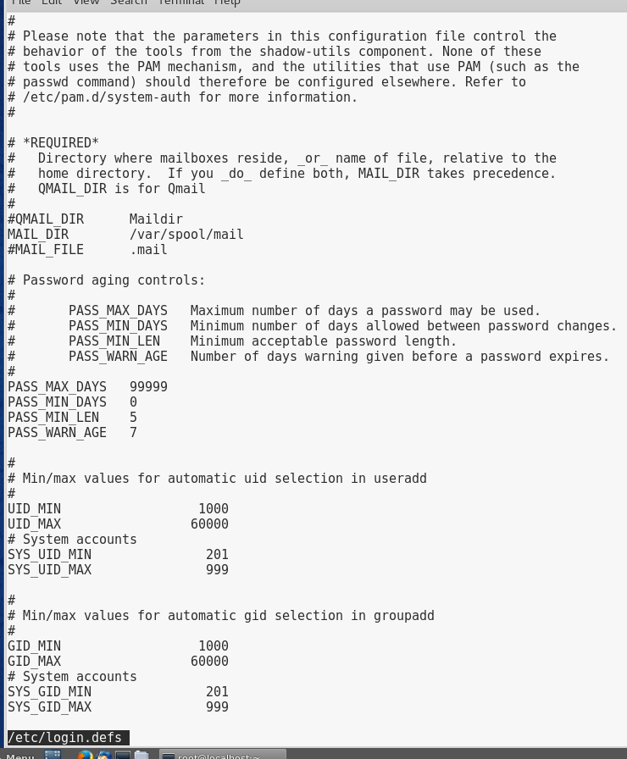

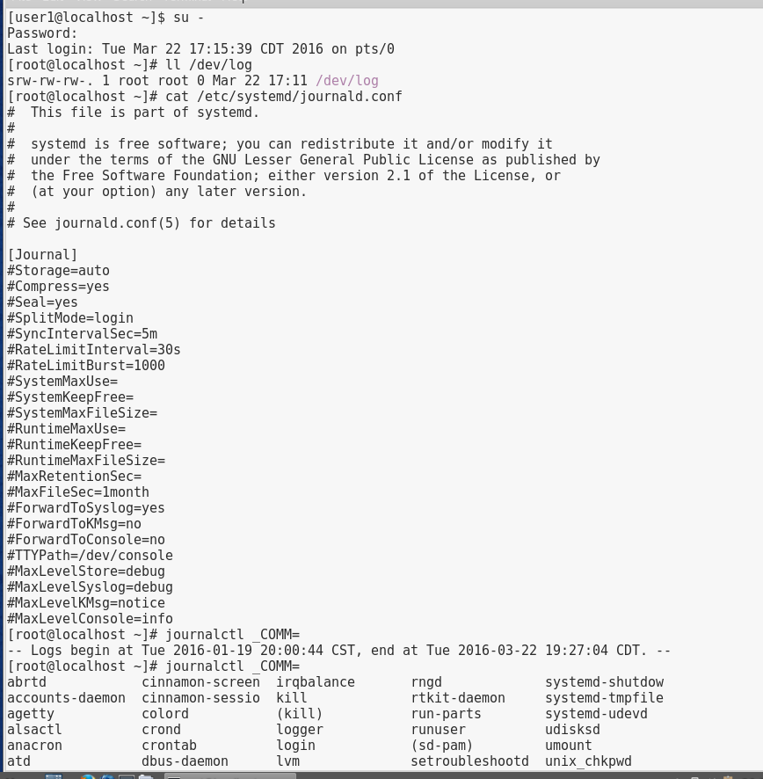

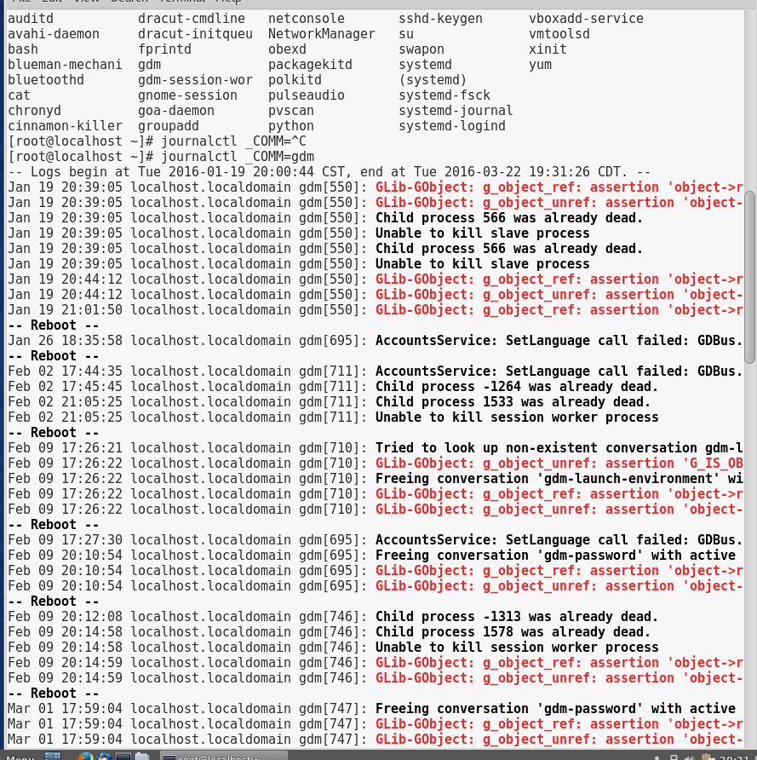

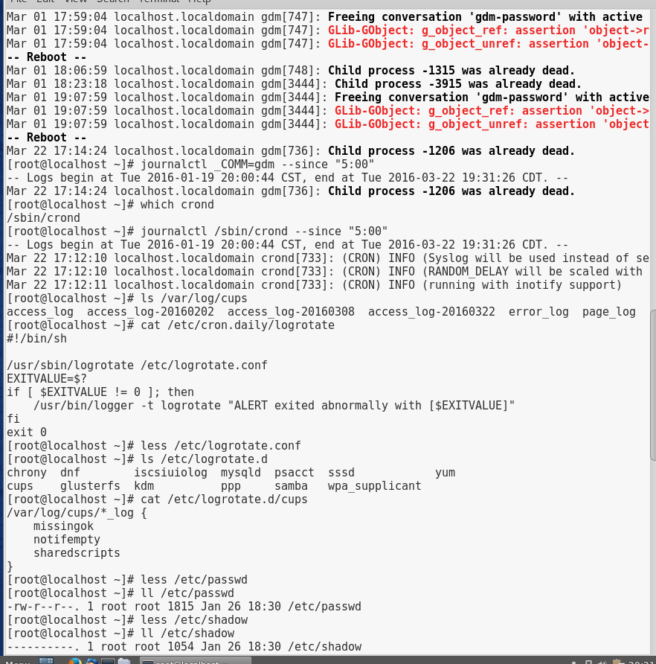

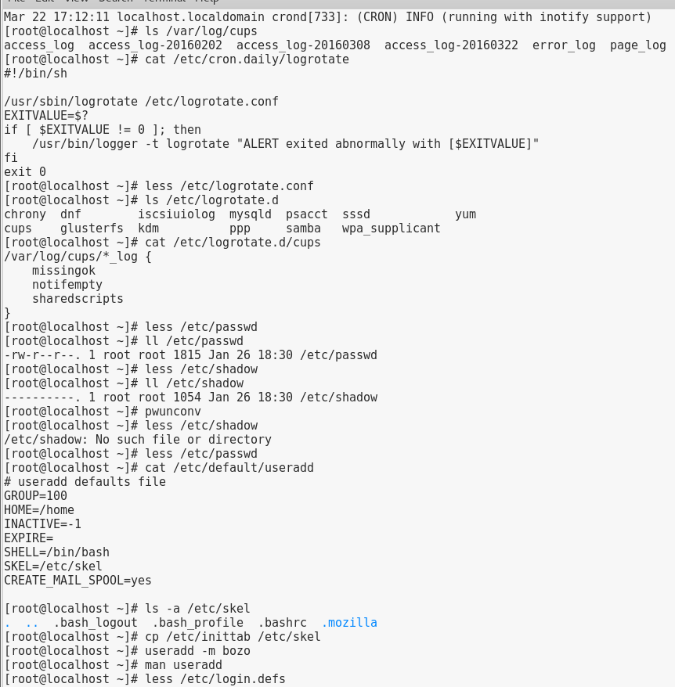

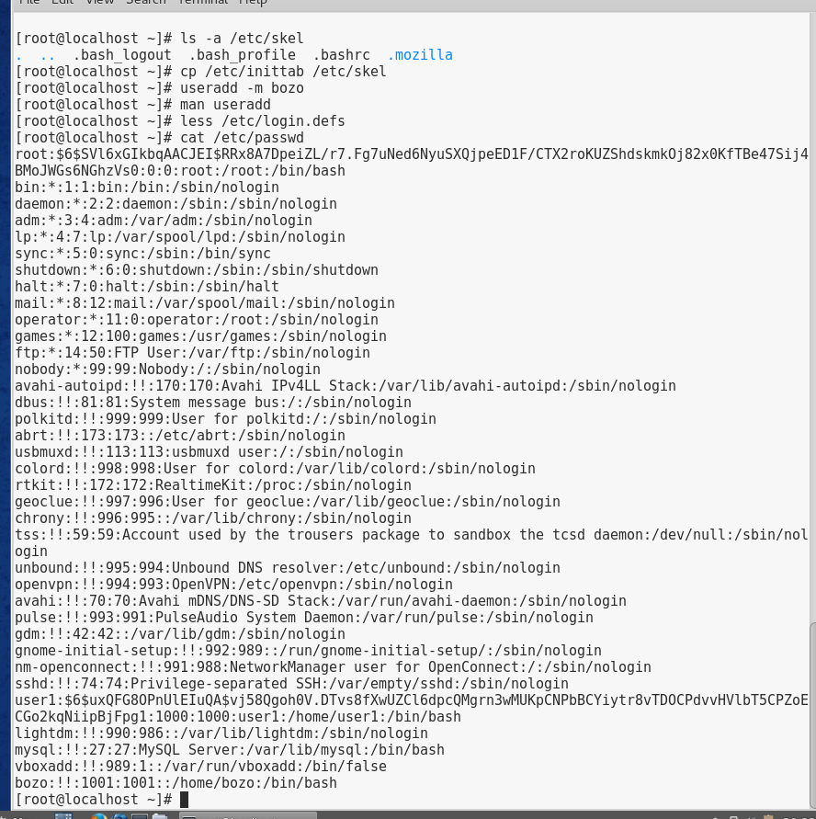

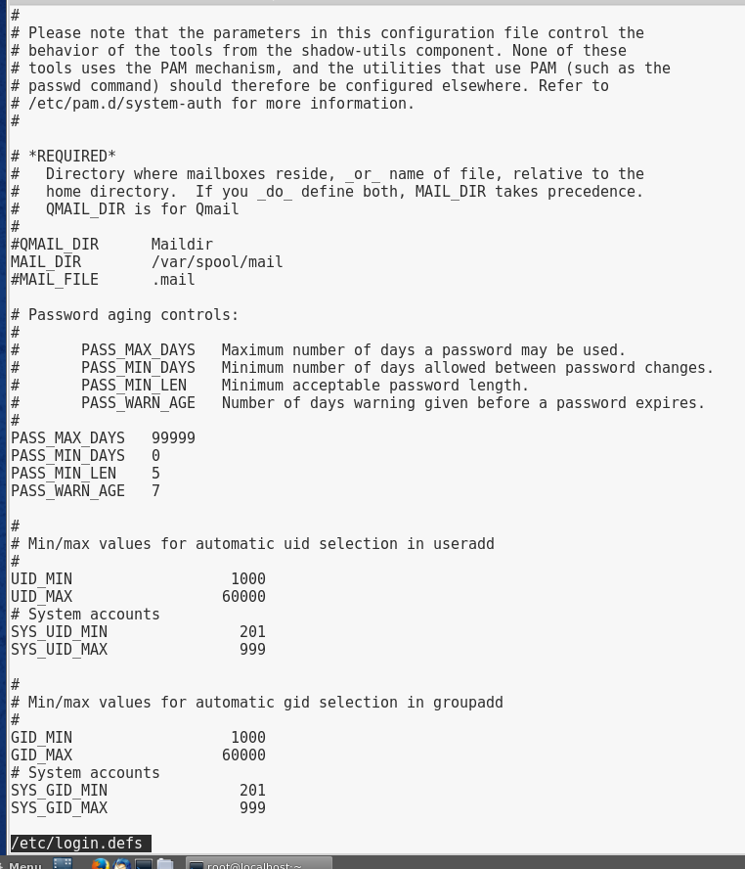

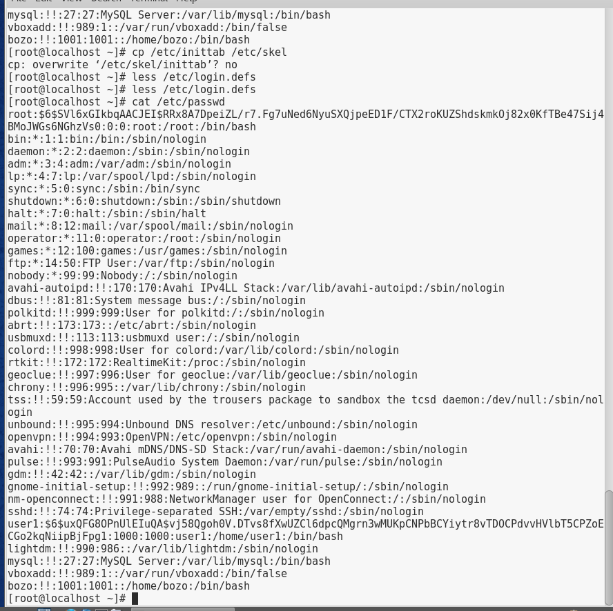

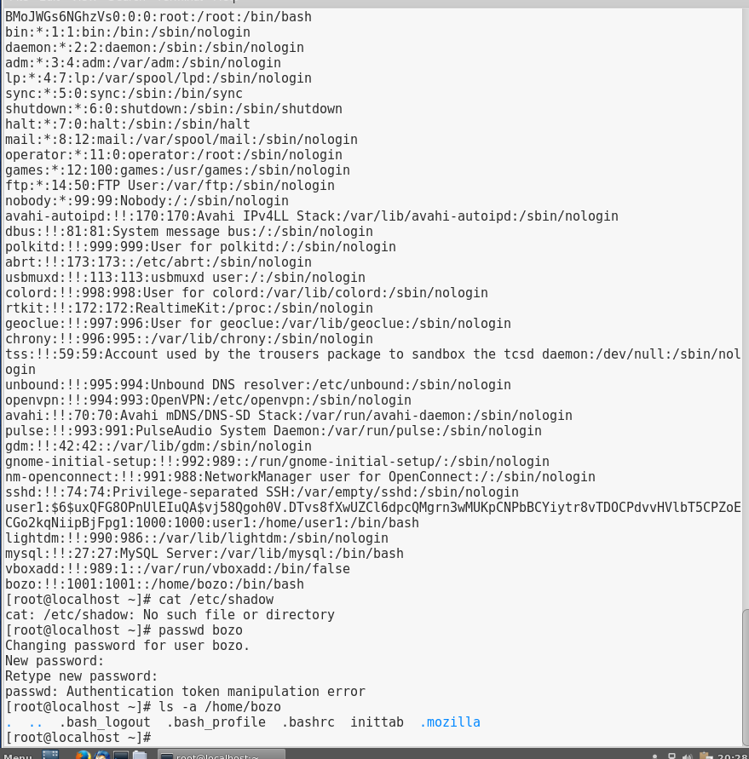

# Project 10-5

In this hands-on project, you modify user accounts on Fedora Linux using command-line utilities.

1. Boot your **Fedora** Linux virtual machine. Login to your chosen desktop environment as **user1** using password **LNXrocks!** and open up a terminal window.
2. At the terminal, become **root** by typing **su -** and press enter and provide **LNXrocks!** as the password.
3. At the command prompt, type **cat /etc/passwd** and press Enter. Record the line used to describe the user bozo. At the command prompt, type **cat /etc/shadow** and press Enter. Record the line used to describe the user bozo.
4. At the command prompt, type **usermod -l bozo2 bozo** and press Enter to change the login name for the user bozo to bozo2. Next, type **cat /etc/passwd** at the command prompt and press Enter. Was the login name changed from bozo to bozo2? Was the UID changed? Was the home directory changed? **Yes and no to the others.**
5. At the command prompt, type **usermod –l bozo bozo2** and press Enter to change the login name for the user bozo2 back to bozo.
6. At the command prompt, type **usermod -u 666 bozo** and press Enter to change the UID of the user bozo to 666. Next, type **cat /etc/passwd** at the command prompt and press Enter. Was the UID changed? **Yes.**
7. At the command prompt, type **usermod -f 14 bozo** and press Enter to disable bozo’s user account 14 days after the password expires. Next, type **cat /etc/shadow** at the command prompt and press Enter. Which field was changed? **Bozo**
8. At the command prompt, type **usermod -e “01/01/2025” bozo** and press Enter to expire bozo’s user account on January 1, 2025. Next, type **cat /etc/shadow** at the command prompt and press Enter. Which field was changed? What does the number represent in this field? **location**
9. At the command prompt, type **chage -m 2 bozo** and press Enter to require that the user bozo wait at least two days before making password changes. Next, type **cat /etc/shadow** at the command prompt and press Enter. Which field was changed? **group ID**
10. At the command prompt, type **chage -M 40 bozo** and press Enter to require that the user bozo change passwords every 40 days. Next, type **cat /etc/shadow** at the command prompt and press Enter. Which field was changed? **user ID info**
11. At the command prompt, type **chage -W 5 bozo** and press Enter to warn the user bozo five days before a password change is required. Next, type **cat /etc/shadow** at the command prompt and press Enter. Which field was changed? **home directory**
12. **Provide screenshot(s) of steps 3 through 11.**

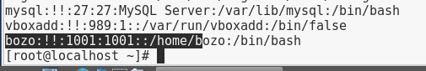

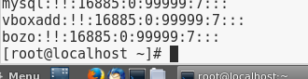

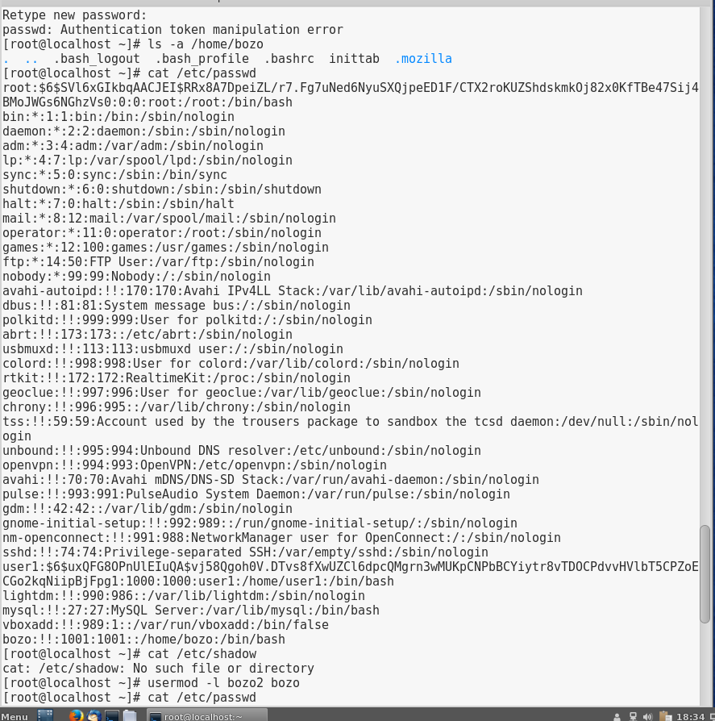

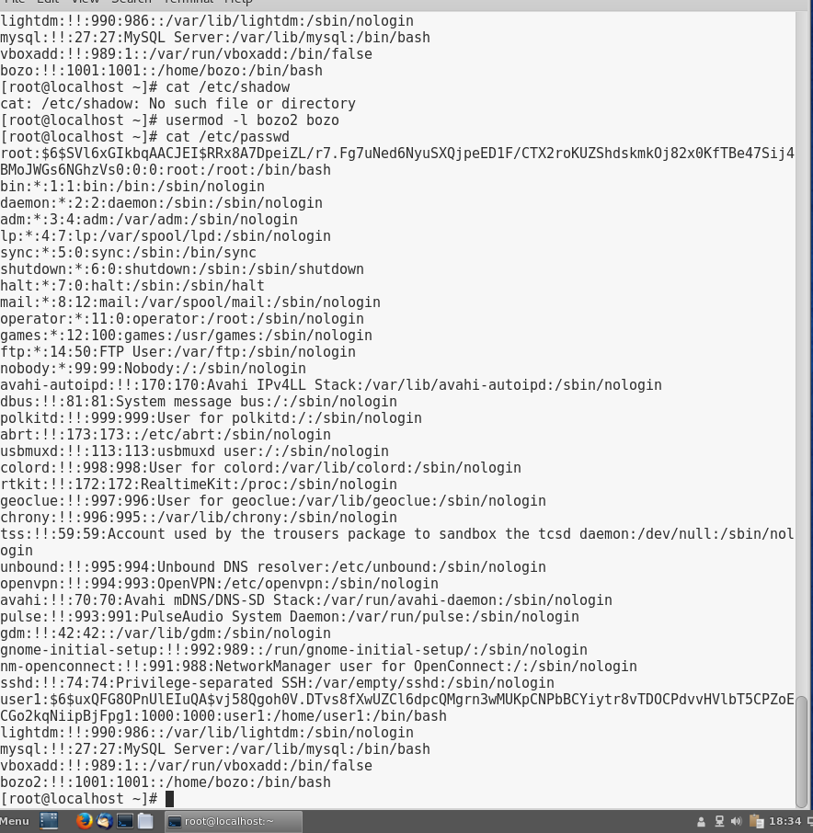

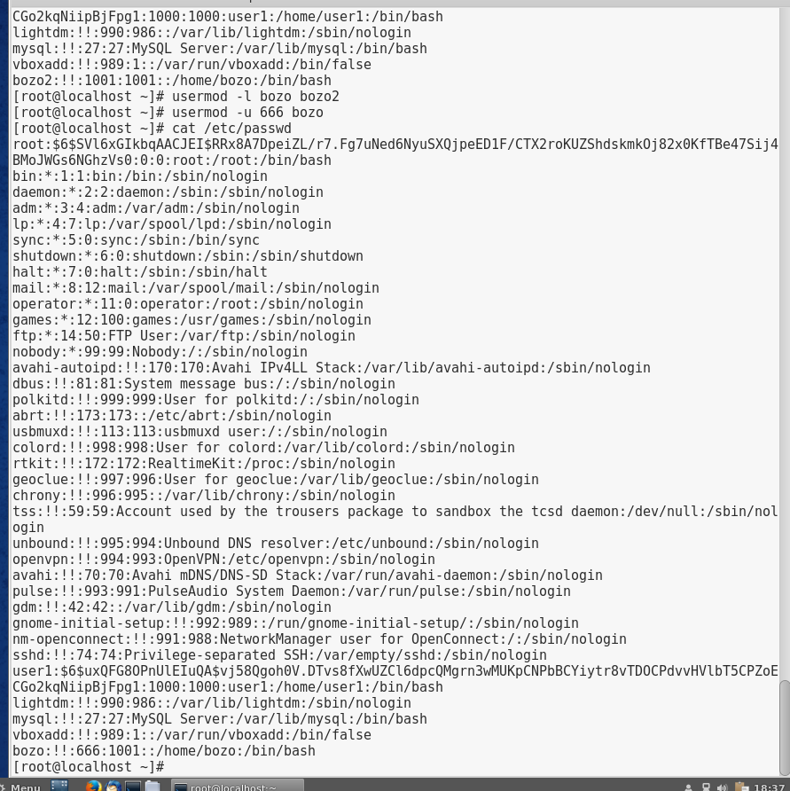

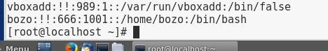

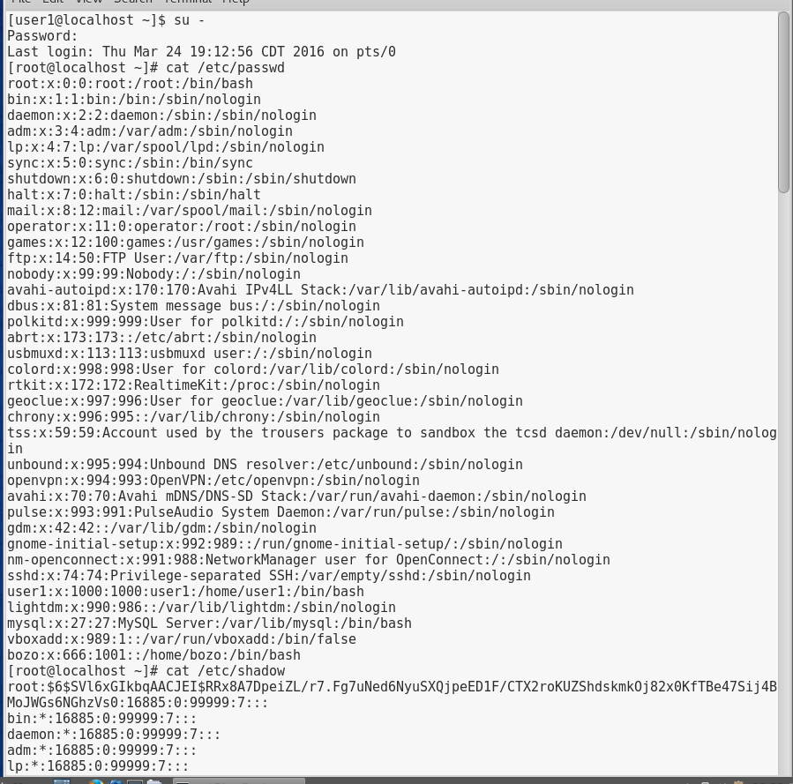

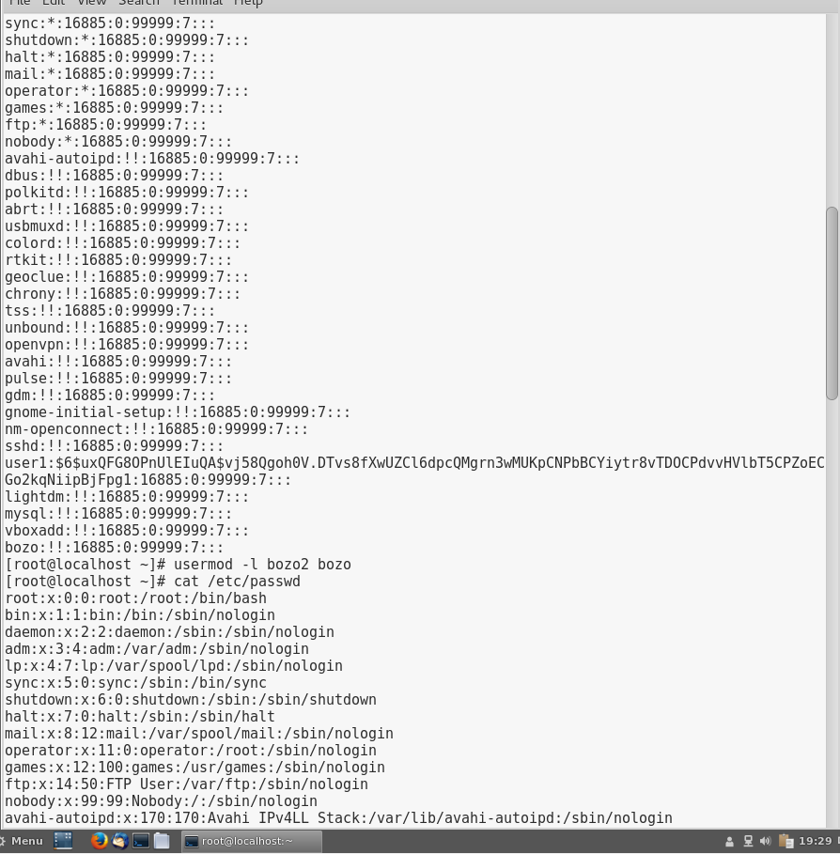

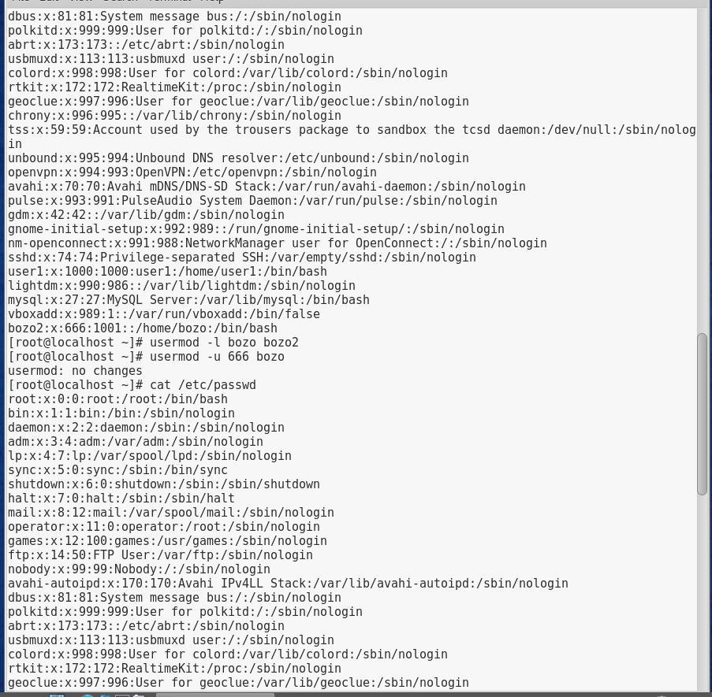

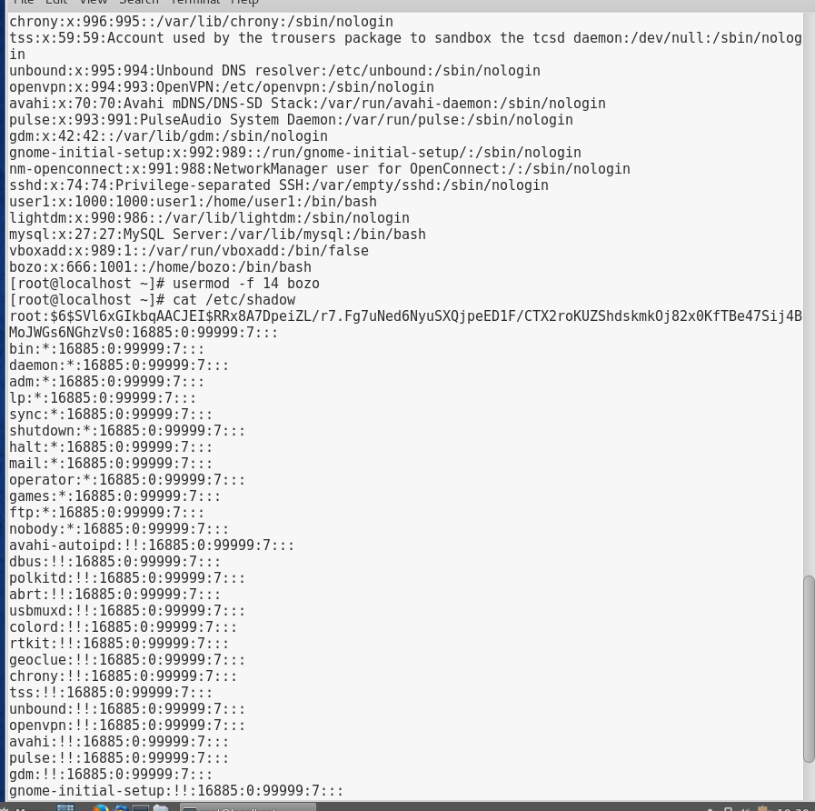

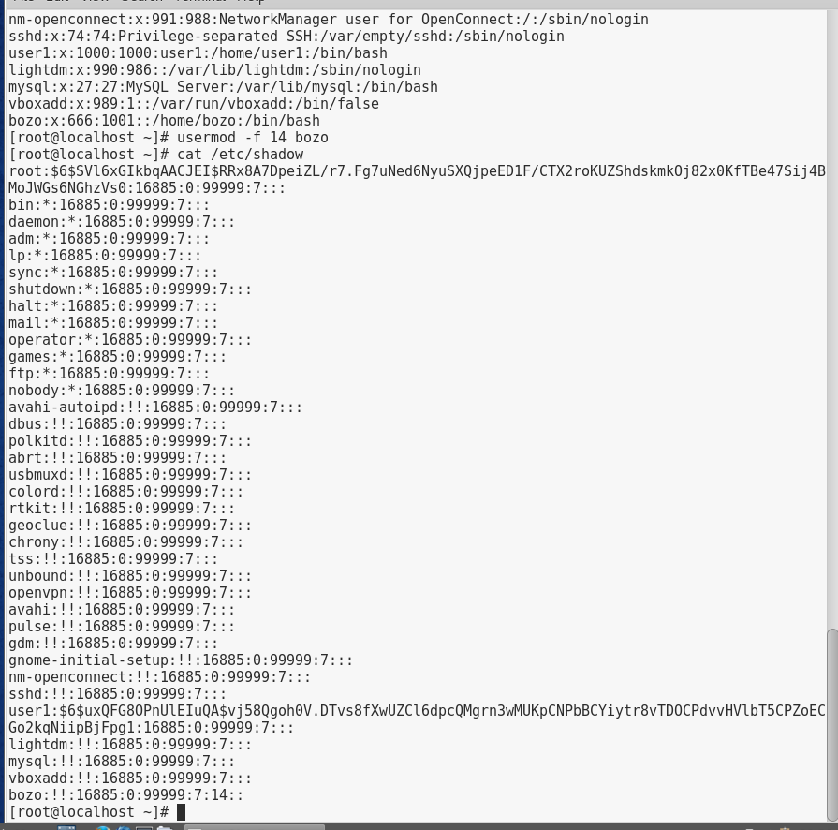

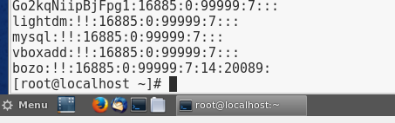

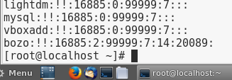

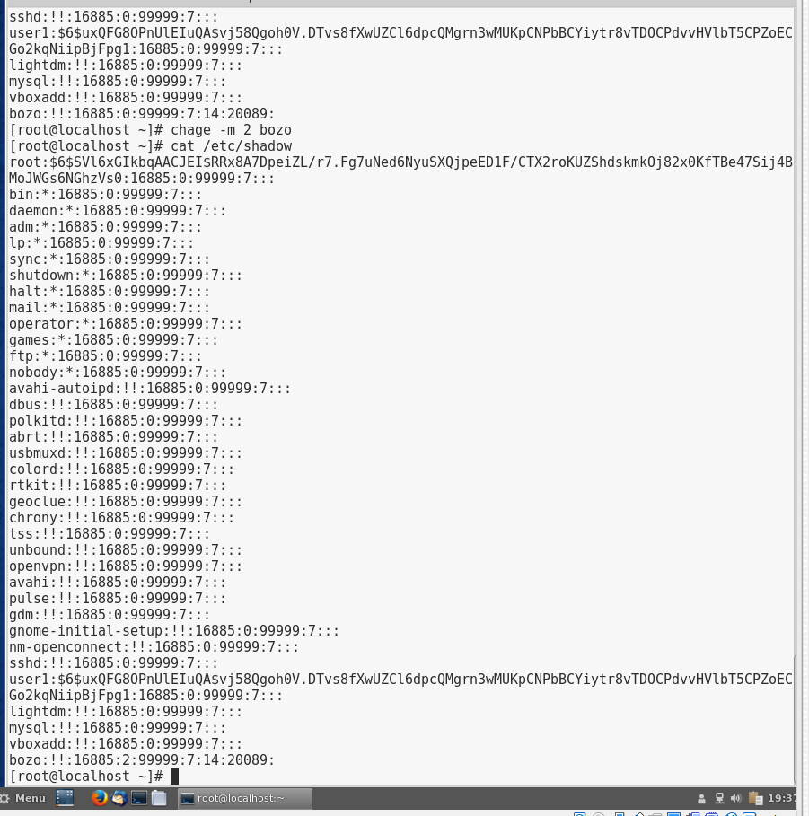

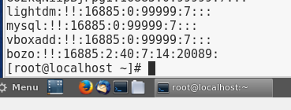

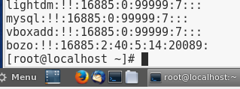

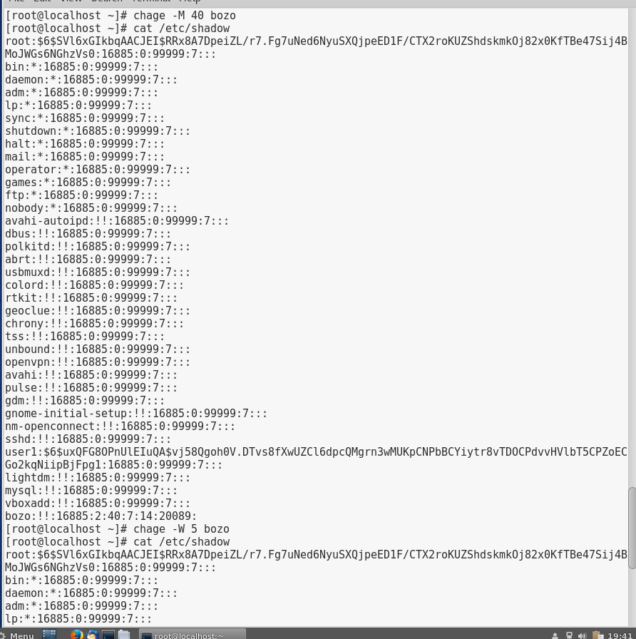

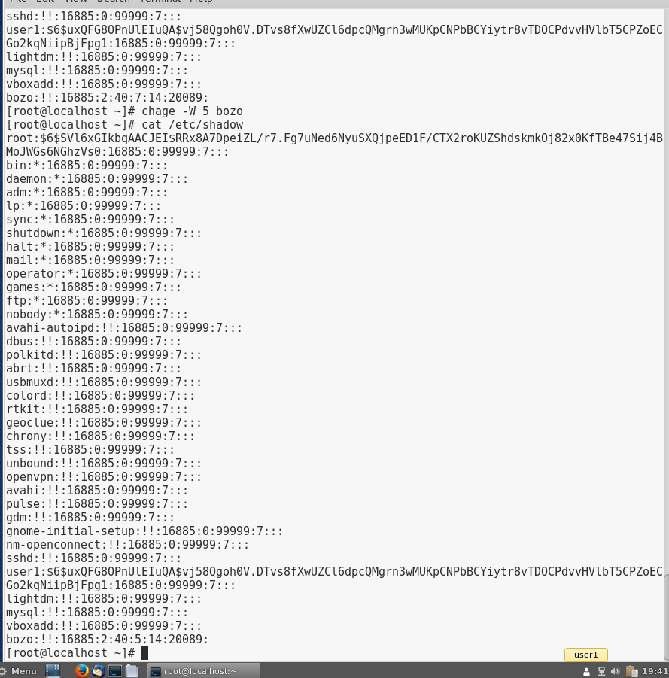

# Project 10-6

In this hands-on project, you lock and unlock user accounts on Fedora Linux using command-line utilities.

1. Boot your **Fedora** Linux virtual machine. Login to your chosen desktop environment as **user1** using password **LNXrocks!** and open up a terminal window.
2. At the terminal, become **root** by typing **su -** and press enter and provide **LNXrocks!** as the password.
3. At the command prompt, type **cat /etc/shadow** and press Enter. Record the encrypted password for bozo’s user account.
4. At the command prompt, type **passwd -l bozo** and press Enter to lock bozo’s user account.
5. At the command prompt, type **cat /etc/shadow** and press Enter. What has been changed regarding the original encrypted password recorded in Step 2? **nothing**
6. Open a new terminal/tab and type **su - bozo** and the password of LNXrocks!. Were you successful? **No**
7. Switch back to your other terminal.
8. At the command prompt, type **passwd -u bozo** and press Enter to unlock bozo’s user account.
9. At the command prompt, type **cat /etc/shadow** and press Enter. Compare the encrypted password for bozo’s user account to the one recorded in Step 2.
10. Open a new terminal/tab and type **su - bozo** and the password of LNXrocks!. Were you successful? **no**
11. Type **exit** and press Enter to log out of your shell.
12. Switch back to your other terminal.
13. At the command prompt, type **chsh -s /bin/false bozo** and press Enter to change bozo’s shell to /bin/false. What message did you receive? **Changing shell for bozo. Chsh: warning: “bin/false” is not listed in /etc/shells** Type **cat /etc/passwd | grep bozo** at a command prompt to verify that the shell was changed to /bin/ false for bozo’s user account.
14. Open a new terminal/tab and type **su - bozo** and the password of LNXrocks!. Were you successful? **no**
15. Switch back to your other terminal.
16. At the command prompt, type **chsh -s /bin/bash bozo** and press Enter to change bozo’s shell to /bin/bash.
17. Open a new terminal/tab and type **su - bozo** and the password of LNXrocks!. Were you successful? **Nope**
18. Type exit and press Enter to log out of your shell.
19. Switch back to your other terminal
20. **Provide screenshot(s) of steps 3 through 19.**

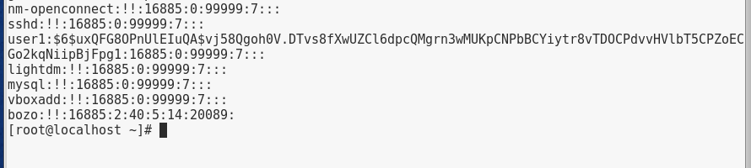

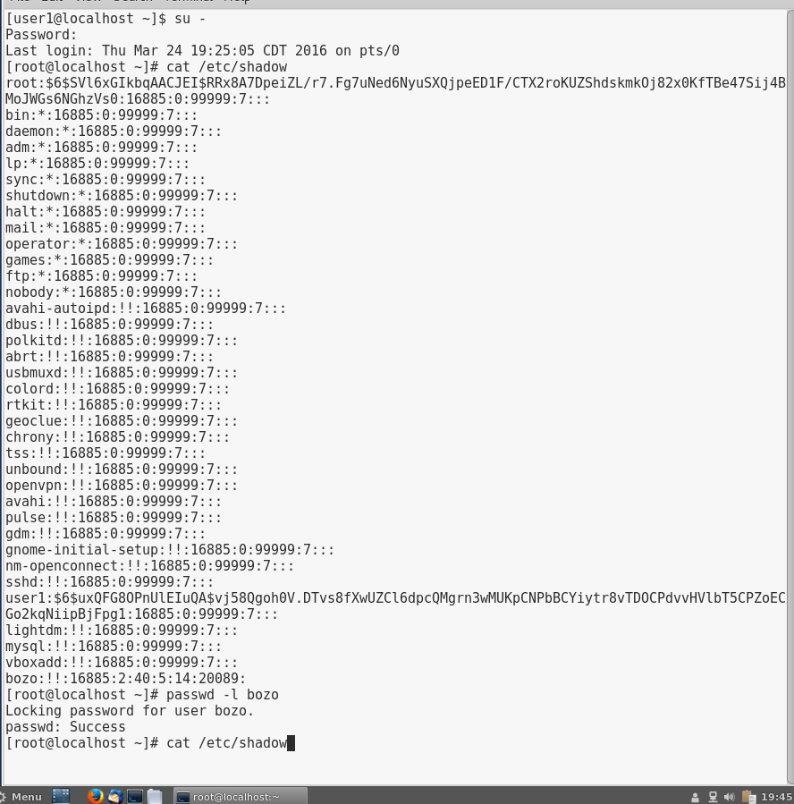

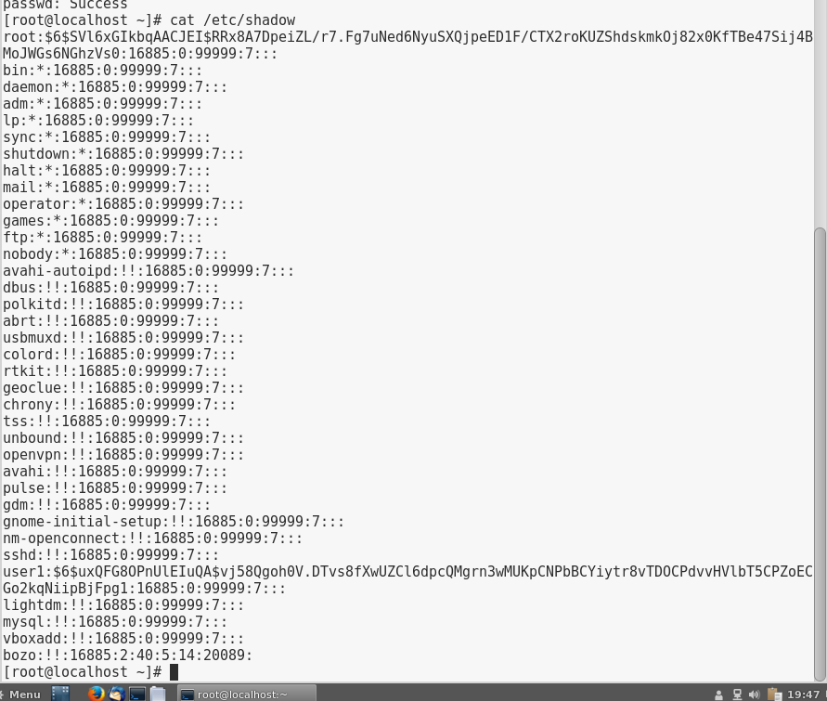

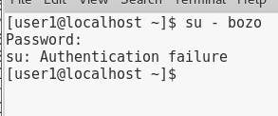

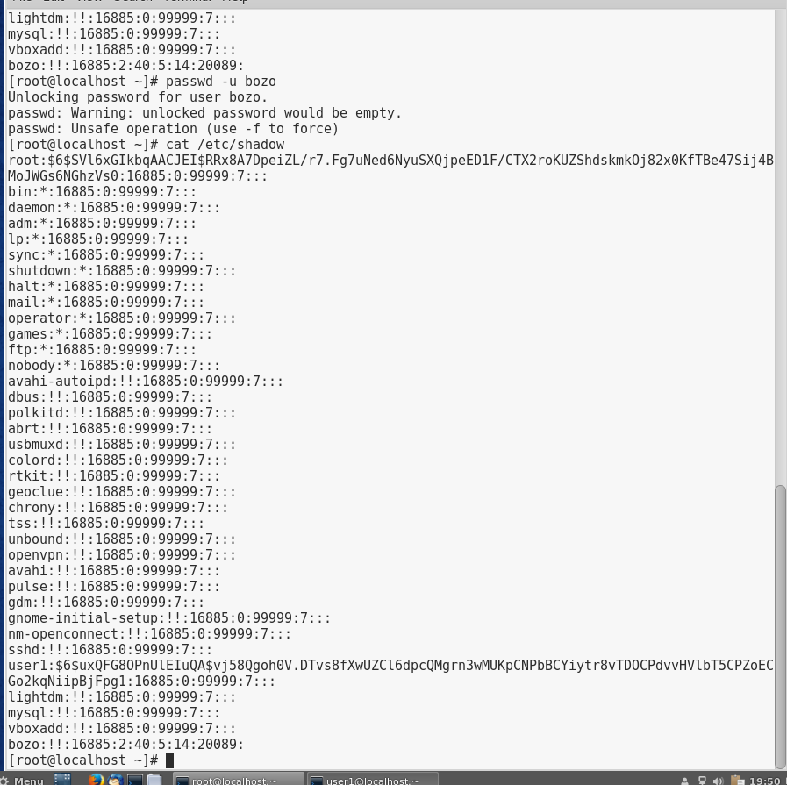

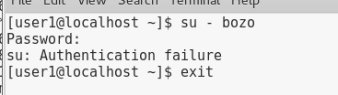

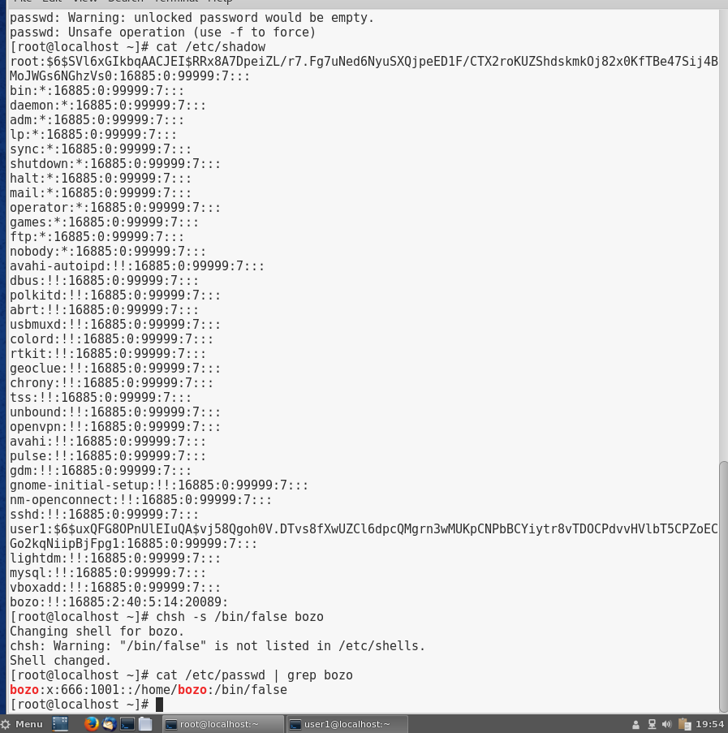

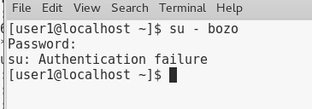

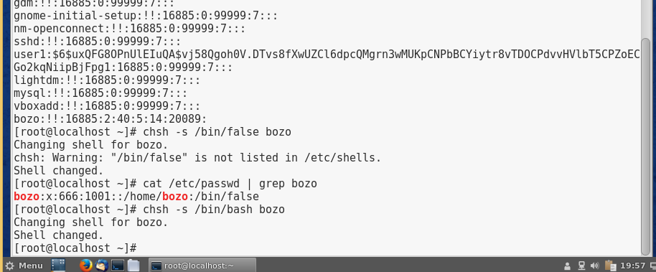

# Project 10-7

In this hands-on project, you remove a user account on Fedora Linux and create a new user account in its place using command-line utilities.

1. Boot your **Fedora** Linux virtual machine. Login to your chosen desktop environment as **user1** using password **LNXrocks!** and open up a terminal window.
2. At the terminal, become **root** by typing **su -** and press enter and provide **LNXrocks!** as the password.
3. At the command prompt, type **ls -la /home/bozo** and press Enter. Who owns most files in this directory? Why? **Bozo, because the owner permissions were changed**
4. At the command prompt, type **userdel bozo** and press Enter. Was the home directory removed for bozo as well?
5. At the command prompt, type **ls -la /home/bozo** and press Enter. Who owns most files in this directory? Why? **666, because we just deleted bozo so it refers back to the last owner that was entered**
6. At the command prompt, type **useradd -m -u 666 bozoette** and press Enter. What do the –m and the –u options do in this command? **Specifies the home directory and specifies the UID of the user account**
7. At the command prompt, type **passwd bozoette** and press Enter. Enter the password of LNXrocks! and press Enter. Enter the password of LNXrocks! again to confirm and press Enter.
8. At the command prompt, type **cat /etc/passwd** and press Enter. What is bozoette’s home directory? What is bozoette’s UID? **/bin/bash and 666**
9. At the command prompt, type **ls -la /home/bozo** and press Enter. Who owns most files in this directory? Why? Can bozoette manage these files? **Bozoette and yes**
10. **Provide screenshot(s) of steps 3 through 9.**

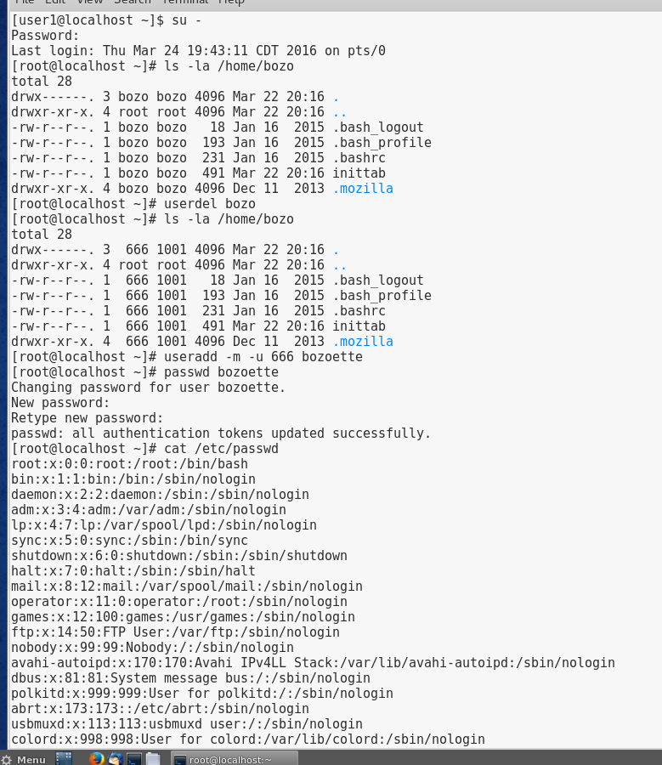

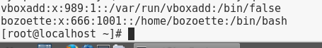

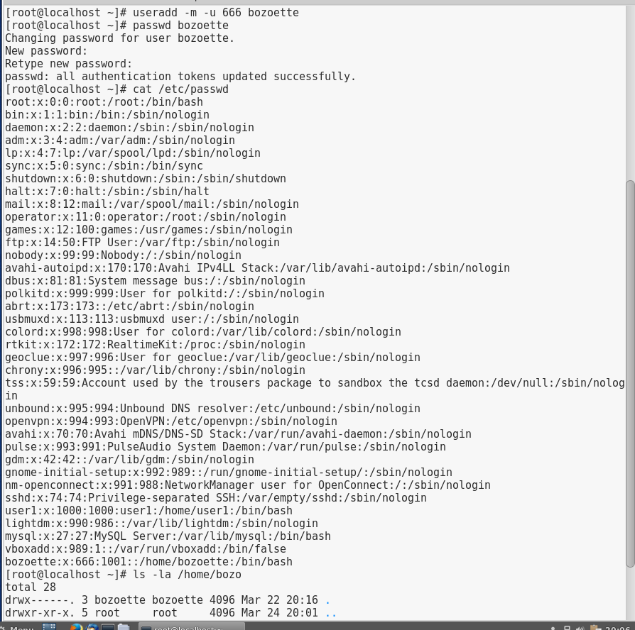

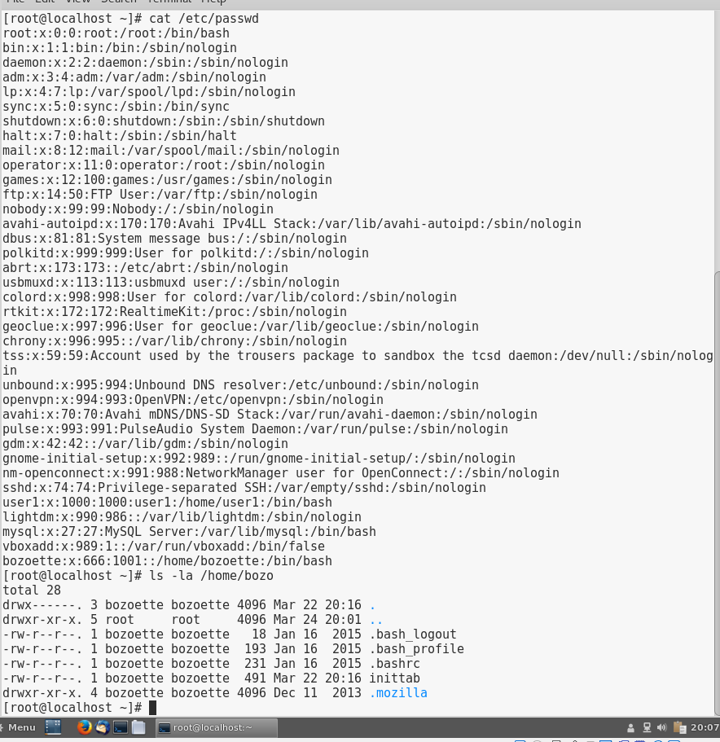

# Project 10-8

In this hands-on project, you create, use, and delete groups on Fedora Linux using command-line utilities.

1. Boot your **Fedora** Linux virtual machine. Login to your chosen desktop environment as **user1** using password **LNXrocks!** and open up a terminal window.
2. At the terminal, become **root** by typing **su -** and press enter and provide **LNXrocks!** as the password.
3. At the command prompt, type **vi /etc/group** and press Enter to open the /etc/group file in the vi editor. Add a line to the bottom of this file that reads:

groupies:x:1234:root,bozoette

This adds a group to the system with a GID of 1234, the members root, and bozoette. When finished, save and quit the vi editor.

1. Open new terminal/tab and become user bozoette by typing **su - bozoette** and the password of LNXrocks!.
2. At the command prompt, type **groups** and press Enter. Of which groups is bozoette a member? **groupies**
3. At the command prompt, type **id** and press Enter. Which group is the primary group for the user bozoette? **See screenshot provided**
4. At the command prompt, type **touch file1** and press Enter to create a new file called file1 in the current directory.
5. At the command prompt, type **ll** and press Enter. Who is the owner and group owner of the file file1? **bozoette**
6. At the command prompt, type **newgrp groupies** and press Enter to temporarily change bozoette’s primary group to groupies.
7. At the command prompt, type **touch file2** and press Enter to create a new file called file2 in the current directory.
8. At the command prompt, type **ll** and press Enter. Who is the owner and group owner of the file file2? **Bozoette and groupies**
9. Type exit and press Enter to log out of the new shell created when you used the newgrp command. Next, type exit and press Enter to log out of your shell.
10. Switch back to your initial terminal.
11. At the command prompt, type **groupdel groupies** and press Enter to remove
12. **Provide screenshot(s) of steps 3 through 14.**

